ALGORITHM DETAILS

Algorithm Details
1. Adaptive Learning Algorithm
Purpose: Adjust difficulty of tasks based on child’s performance.
Pseudo-code:
Algorithm Adaptive_Learning
Input: Task_set T, Child_profile C
Output: Updated task difficulty

1. Initialize difficulty_level ← baseline from C
2. For each task t in T do
Present t to child
Record performance metrics: accuracy, time_taken, errors
3. Evaluate performance_score ← f(accuracy, time_taken, errors)
4. If performance_score > Upper_threshold then
Increase difficulty_level
Else if performance_score < Lower_threshold then
Decrease difficulty_level
Else
Maintain same difficulty_level
5. Store performance in database
6. Provide feedback to child (visual/audio cues)
7. Update caregiver dashboard
End

2. Gamification & Reward Algorithm
Purpose: Motivate children using points, badges, and AR effects.
Pseudo-code:
Algorithm Gamification_System
Input: Child_performance P
Output: Rewards R

1. Initialize points ← 0
2. For each completed task:
If task_success = TRUE then
points ← points + 10
Else
points ← points + 2 // encourage effort
3. If points ≥ Milestone then
Award Badge or AR_Reward
4. Update reward_history
5. Display rewards to child
End

3. Multimodal Interaction Algorithm
Purpose: Enable accessibility via touch, voice, or gesture.
Pseudo-code:
Algorithm Multimodal_Input
Input: User_input (touch/voice/gesture)
Output: System_action

1. Detect input_mode
2. If input_mode = voice then
Use Speech-to-Text API
Else if input_mode = gesture then
Use ARCore/ARKit to recognize gestures
Else
Process as touch input
3. Map input to action (select option, navigate, confirm)
4. Provide feedback (highlight, sound, vibration)
End
4. Progress Monitoring Algorithm
Purpose: Track improvement trends and generate caregiver insights.
Pseudo-code:
Algorithm Progress_Tracking
Input: Daily_logs D
Output: Progress_report R

1. Collect data from all sessions in D
2. Calculate weekly_metrics:
memory_score ← avg(memory_tasks)
attention_score ← avg(attention_tasks)
problem_solving ← avg(problem_tasks)
3. Compare current_metrics with previous week
4. If regression detected then
Trigger Alert to caregiver
5. Generate visual graphs
6. Send report R to caregiver/therapist dashboard
End

5. Caregiver AI Assistant Algorithm
Purpose: Summarize progress and give recommendations.
Pseudo-code:
Algorithm Caregiver_AI_Assistant
Input: Progress_data P
Output: Recommendations R

1. Analyze P for patterns (improvement, decline, stagnation)
2. If memory < threshold then
Suggest "shorter memory sessions"
3. If attention improved then
Highlight achievement
4. Generate plain-language summary for caregiver
5. Display suggestions in dashboard
End

6. Social Learning Algorithm
Purpose: Allow children to play cooperative cognitive games.
Pseudo-code:
Algorithm Social_Learning
Input: Child_profile C
Output: Match and Game_session

1. Match child with peer of similar profile
2. Initiate secure WebRTC connection
3. Launch collaborative game
4. Monitor performance of both players
5. If task_success = TRUE then
Award team points
6. Store session data in database
End

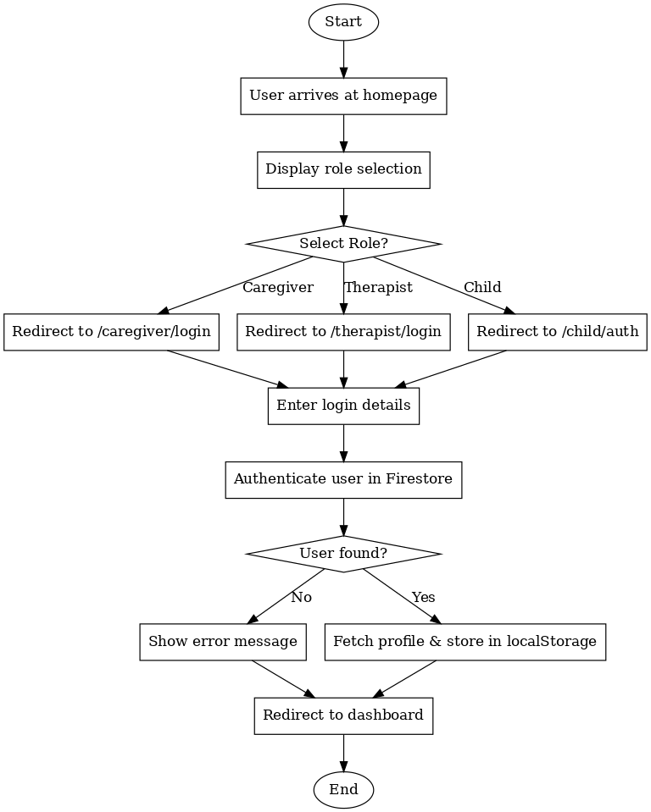
FLOW CHART :

AUTHENTICATION ALGORITHM FLOW CHART:
